Annual Examination [2023-24]
Class: XI [Painting] Date: 05/03/2024 Time: 2 Hrs. MM-30
- Multiple choice questions :- 1×8=8
- A shrine of square plan is called
i) panchayatana ii)kuta iii) gaja prishtha iv)chaitya
- A fine-grained variegated chalcedony, its colours arranged in stripes, blended in clouds or showing moss like forms.
i) lime ii)chert iii)Agate iv)lapis lazuli
- Ribbed, lenticular or globoid part resembling the amala (Indian gooseberry fruit) crowning the top of the North Indian style shikhara
i) Gopuram ii) chaitya iii) Chhatra iv)Amalaka
- Semi-circular structure typically used for Buddhist stupa
i) Rekha prasad ii) Harmika iii)Anda iv)Chakra
- An ornamental design consisting of intertwined flowing lines, leaves and flowers, a feature of the Indo-Islamic architecture.
i)Jali ii) Arabesque iii)Dargah iv)Mimbar
- Circular embossed decorations, usually in stone of contrasting colours located on either side of an arch and within the spandrels.
i) Faience ii) Corbel iii) Lintel iv)Bosses
- A religion originated in the sixteenth century BCE with the preachings of Buddha.
i) Hinduism ii)Islam iii) Buddhism iv)Jainism
- A pointed tool of flint or stone with a transverse edge made by the removal of one or more flakes. Used for working bone, antler and ivory, and, perhaps, for engraving.
i) Chamfer ii)Burin iii) Crystal iv)Intaglio
B. Short Answer Type Questions:- 5×2=10
1. According to your observation how did the people of prehistoric times select themes for their paintings?
2. Write the 4 names of Harappan sites India.
OR
Write a short note on Mother goddess from Harappa.
3. Describe the Jain Tirthankar from Gupta period 5th century CE.
4. Write a note on Trimurti from Elephanta.
OR
Write a note on Qutub Minar.
5. Identify the monument and label it.
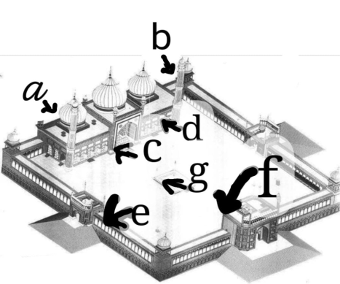
C. Long answer type questions:- 2×6=12
1. Explain Shadang
OR
Write a note on Islamic Architecture in India.
2. Describe Art during Mauryan period.
OR
Write a descriptive note on ancient temple structure in India.

